CYK Algorithm
- CYK Algorithm is a membership algorithm of context free grammar. It is used to decide whether a given string belongs to the language of grammar or not.
- It is also known as CKY Algorithm or Cocke-Younger-Kasami Algorithm after its inventors.
- CYK Algorithm operates only on Context Free Grammars given in Chomsky Normal Form.

Deciding Membership Using CYK Algorithm-

To decide the membership of any given string, we construct a triangular table where-
- Each row of the table corresponds to one particular length of sub strings.
- Bottom most row corresponds to strings of length-1.
- Second row from bottom corresponds to strings of length-2.
- Third row from bottom corresponds to strings of length-3.
- Top most row from bottom corresponds to the given string of length-n.

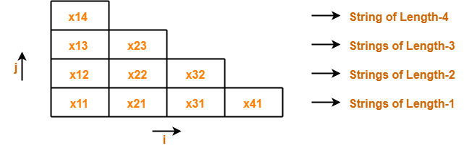

We will fill each box of x_{ij} with its V_{ij}. These notations are given below.

Notation-01: x_{ij}

x_{ij} represents a sub string of “x” starting from location ‘i’ and has length ‘j’.
Example-
Consider x = abcd is a string, then-
Number of sub strings possible = n(n+1)/2 = 4 x (4+1) / 2 = 10
We have-
- x₁₁ = a
- x₂₁ = b
- x₃₁ = c
- x₄₁ = d
- x₁₂ = ab
- x₂₂ = bc
- x₃₂ = cd
- x₁₃ = abc
- x₂₃ = bcd
- x₁₄ = abcd

Notation-02: V_{ij}

V_{ij} represents a set of variables in the grammar which can derive the sub string x_{ij.}
If the set of variables consists of the start symbol, then it becomes sure-
- Sub string x_{ij} can be derived from the given grammar.
- Sub string x_{ij} is a member of the language of the given grammar.

Turing machine
The Turing machine (TM) is a simple mathematical model of a general purpose computer. In other words, Turing machine models the computing power of a computer, i.e, the Turing machine is capable of performing any calculation which can be performed by any computing machine.
A Turing Machine is an accepting device which accepts the languages (recursively enumerable set) generated by type 0 grammars. It was invented in 1936 by Alan Turing.
A Turing Machine (TM) is a mathematical model which consists of an infinite length tape divided into cells on which input is given.
The
block diagram of the basic model for the Turing machine is given in Fig. 9.1.
Each cell can store only one symbol. The input to and the output from the finite state automaton are affected by the R/W head which can examine one cell at a time. In one move, the machine examines the present symbol under the R/W head on the tape and the present state of an automaton to determine

- a new symbol to be written on the tape in the cell under the R/W head,
- a motion of the R/W head along the tape: either the head moves one cell left (L),or one cell right (R),
- the next state of the automaton, and
- Whether to halt or not.

REPRESENTATION OF TURING MACHINES

We can describe a Turing machine employing
- Instantaneous descriptions using move-relations.
- Transition table. And
- Transition diagram (transition graph).

REPRESENTATION BY INSTANTANEOUS DESCRIPTIONS

The present symbol under the R/W head is a_{1 .}The present state is q₃ So a₁ is written to the right of q₃ The nonblank symbols to the left of a₁ form the string, a₄a₁a₂a₁a₂a₂, which is written to the left of q₃

The sequence of nonblank symbols to the right of a₁ is a₄a₂Thus the ill is as given in Fig. 9.3.

REPRESENTATION BY TRANSITION TABLE
We give the definition of δ in the form of a table called the transition table. If
δ (q, a) = (γ, α, β), we write α βγ under the a-column and in the q-row. So if we get α βγ in the table, it means that ex is written in the current cell, βgives the movement of the head (L or R) and γ denotes the new state into which the Turing machine enters.

Consider, for example, a Turing machine with five states q₁, ..., q₅, where q_{l}is the initial state and q₅is the (only) final state. The tape symbols are 0. 1 and b. The transition table given in Table 9.1 describes 8.
REPRESENTATION BY TRANSITION DIAGRAM
In this the states are represented by vertices. Directed edges are used to represent transition of states
The labels are triples of the form (α, β,γ), where α ,β∈𝜏 and γ ∈{L,R}.

When there is a directed edge from q_{i} to q_{j}with label (α, β,γ) it means that δ(q_{i}, α)=(q _{j,} β, γ)

During the processing of an input string, suppose the Turing machine enters q_{i}and the R/W head scans the (present) symbol α As a result the symbol β is written in the cell under the R/W head. The R/W head moves to the left: or to the right depending on y, and the new state is q_{j}

Different types of Turing machines:

- Multi tape Turing machine:

Multi-tape Turing Machines have multiple tapes where each tape is accessed with a separate head. Each head can move independently of the other heads. Initially the input is on tape 1 and others are blank. At first, the first tape is occupied by the input and the other tapes are kept blank. Next, the machine reads consecutive symbols under its heads and the TM prints a symbol on each tape and moves its heads.

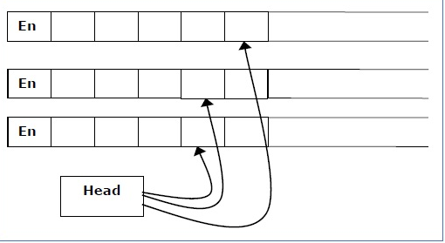

A Multi-tape Turing machine can be formally described as a 6-tuple (Q, 𝜏, B, δ, q₀, F) where −
- Q is a finite set of states
- 𝜏 is the tape alphabet
- B is the blank symbol
- δ is a relation on states and symbols where
δ: Q × 𝜏 ^{k} → Q × (𝜏 × {Left_shift, Right_shift, No_shift })^{k}
where there is k number of tapes
- q₀ is the initial state
- F is the set of final states
Note − Every Multi-tape Turing machine has an equivalent single-tape Turing machine.

- Multitrack Turing machine:

Multi-track Turing machines, a specific type of Multi-tape Turing machine, contain multiple tracks but just one tape head reads and writes on all tracks. Here, a single tape head reads n symbols from n tracks at one step. It accepts recursively enumerable languages like a normal single-track single-tape Turing Machine accepts.
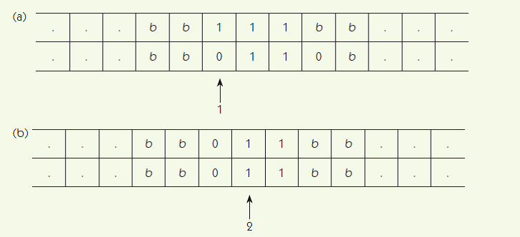

A Multi-track Turing machine can be formally described as a 6-tuple (Q, 𝜏, ∑, δ, q₀, F) where −
- Q is a finite set of states
- 𝜏 is the tape alphabet
- ∑ is the input alphabet
- δ is a relation on states and symbols where
δ(Q_{i}, [a₁, a₂, a₃,....]) = (Q_{j}, [b₁, b₂, b₃,....], Left_shift or Right_shift)
- q₀ is the initial state
- F is the set of final states

- Nondeterministic Turing Machine

A nondeterministic Turing machine is a Turing machine which, like nondeterministic finite automata, at any state it is in and for the tape symbol it is reading, can take any action selecting from a set of specified actions rather than taking one definite predetermined action. Even in the same situation it may take different actions at different times. Here an action means the combination of writing a symbol on the tape, moving the tape head and going to a next state.

A non-deterministic Turing machine can be formally defined as a 6-tuple (Q, 𝜏, ∑, δ, q₀, B, F) where −
- Q is a finite set of states
- 𝜏 is the tape alphabet
- ∑ is the input alphabet
- δ is a transition function;
δ : Q × X → P(Q × X × {Left_shift, Right_shift}).
- q₀ is the initial state
- B is the blank symbol
- F is the set of final states

- Semi Infinite Length Turing Machine:
A Turing Machine with a semi-infinite tape has a left end but no right end. The left end is limited with an end marker.

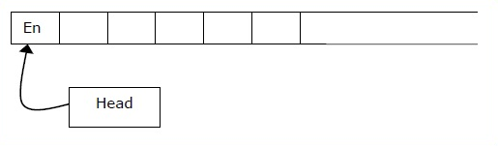
The infinite length input string is initially written on the tape in contiguous tape cells.
The machine starts from the initial state q₀ and the head scans from the left end marker ‘End’. In each step, it reads the symbol on the tape under its head. It writes a new symbol on that tape cell and then it moves the head either into left or right one tape cell. A transition function determines the actions to be taken.
It has two special states called accept state and reject state. If at any point of time it enters into the accepted state, the input is accepted and if it enters into the reject state, the input is rejected by the TM. In some cases, it continues to run infinitely without being accepted or rejected for some certain input symbols.

Linear Bounded Automaton:

A linear bounded automaton is a nondeterministic Turing machine which has a single tape whose length is not infinite but bounded by a linear function of the length of the input string i,e.the tape is limited in size to the size of input. The models can be described formally by the following set format:
M = (Q.,∑, 𝜏, δ qo, b, ¢ $, F)

In LBD head not allowed to move beyond the input.
All the symbols have the same meaning as in the basic model of Turing machines with the difference that the input alphabet ∑ contains two special symbols ¢ and $. ¢ is called the left-end marker which is entered in the leftmost cell of the input tape and prevents the R/W head from getting off the left end of the tape. $ is called the right-end marker which is entered in the rightmost cell of the input tape and prevents the R/W head from getting off the right end of the tape. Both the end markers should not appear on any other cell within the input tape, and the R/W head should not print any other symbol over both the end markers.

The above model of LBA can be represented by the block diagram of Fig. 9.11. There are two tapes: one is called the input tape, and the other, working tape.

On the input tape the head never prints and never moves to the left. On the working tape the head can modify the contents in any way, without any restriction.

In the case of LBA, an ID is denoted by (q, w. k), where q ∈ Q . w ∈𝜏and k is some integer between 1 and n. The transition of IDs is similar except that k changes to k - 1 if the R/W head moves to the left and to k + 1 if the head moves to the right.

The language accepted by LBA is defined as the set
for some q E F and for some integer i between 1 and n},

Context Sensitive language:
Context-Sensitive Grammar –
A Context-sensitive grammar is an Unrestricted grammar in which all the productions are of form –
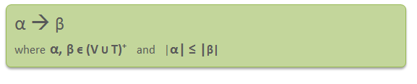
Where α and β are strings of non-terminals and terminals.
Context-sensitive grammars are more powerful than context-free grammars because there are some languages that can be described by CSG but not by context-free grammars and CSL are less powerful than Unrestricted grammar.

Context-sensitive grammar has 4-tuples. G = {V, T, P, S}, Where
V= Set of non-terminal symbols
T = Set of terminal symbols
P = Start symbol of the production
S= Finite set of productions
All rules in P are of the form α₁ A α₂ –> α₁ β α₂

Context-sensitive Language: The language that can be defined by context-sensitive grammar is called CSL. Properties of CSL are:

- Union, intersection and concatenation of two context-sensitive languages is context-sensitive.
- Complement of a context-sensitive language is context-sensitive.

Example –

Consider the following CSG.
S → abc/aAbc
Ab → bA
Ac → Bbcc
bB → Bb
aB → aa/aaA

What is the language generated by this grammar?
Solution:
S → aAbc
→ abAc
→ abBbcc
→ aBbbcc
→ aaAbbcc
→ aabAbcc
→ aabbAcc
→ aabbBbccc
→ aabBbbccc
→ aaBbbbccc
→ aaabbbccc
The language generated by this grammar is {a^{n}b^{n}c^{n} | n≥1}.

Un restricted Grammar

A Grammar G=(V,T,P,S) is called unrestricted if all the Productions are of the form
u v ,
Where u is in (V U T)⁺ and v is in (V U T)*

In an unrestricted grammar, essentiallyno conditions are imposed on the productions, any number of variables and terminals can be on the left or right, and these can occur in any order as the left side of a production

Recursive and Recursively Enumerable Languages
There are three possible outcomes of executing a Turing machine over a given input. The Turing machine may
- Halt and accept the input;
- Halt and reject the input; or
- Never halt.

If any Turing machine can be designed to accept all string of the given language, then the language is called recursively enumerable language.

A language is recursively enumerable if there exists a Turing machine that accepts every string of the language, and does not accept strings that are not in the language. (Strings that are not in the language may be rejected or may cause the Turing machine to go into an infinite loop.)
RE languages or type-0 languages are generated by type-0 grammars.
A language is recursive if there exists a Turing machine that accepts every string of the language and rejects every string (over the same alphabet) that is not in the language.
Clearly, every recursive language is also recursively enumerable. It is not obvious whether every recursively enumerable language is also recursive.
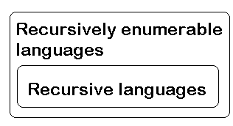
Closure Properties of Recursive Languages
- Union: If L1 and If L2 are two recursive languages, their union L1∪L2 will also be recursive because if TM halts for L1 and halts for L2, it will also halt for L1∪L2.
- Concatenation: If L1 and If L2 are two recursive languages, their concatenation L1.L2 will also be recursive. For Example:
- L1= {a^{n}b^{n}c^{n}|n>=0}
- L2= {d^{m}e^{m}f^{m}|m>=0}
- L3= L1.L2
- = {a^{n}b^{n}c^{n}d^{m} e^{m}f^{m}|m>=0 and n>=0} is also recursive.

L1 says n no. of a’s followed by n no. of b’s followed by n no. of c’s. L2 says m no. of d’s followed by m no. of e’s followed by m no. of f’s. Their concatenation first matches no. of a’s, b’s and c’s and then matches no. of d’s, e’s and f’s. So it can be decided by TM.
- Kleene Closure: If L1is recursive, its kleene closure L1* will also be recursive. For Example:
L1= {a^{n}b^{n}c^{n}|n>=0}
L1*= { a^{n}b^{n}c^{n}||n>=0}* is also recursive.

Chomsky Hierarchy

According to Chomsky hierarchy, grammars are divided of 4 types. This hierarchy of grammars was described by Noam Chomsky in 1956

Type 0 known as unrestricted grammar.
Type 1 known as context sensitive grammar.
Type 2 known as context free grammar.
Type 3 Regular Grammar.

The following table summarizes each of Chomsky's four types of grammars, the class of language it generates, the type of automaton that recognizes it, and the form its rules must have.

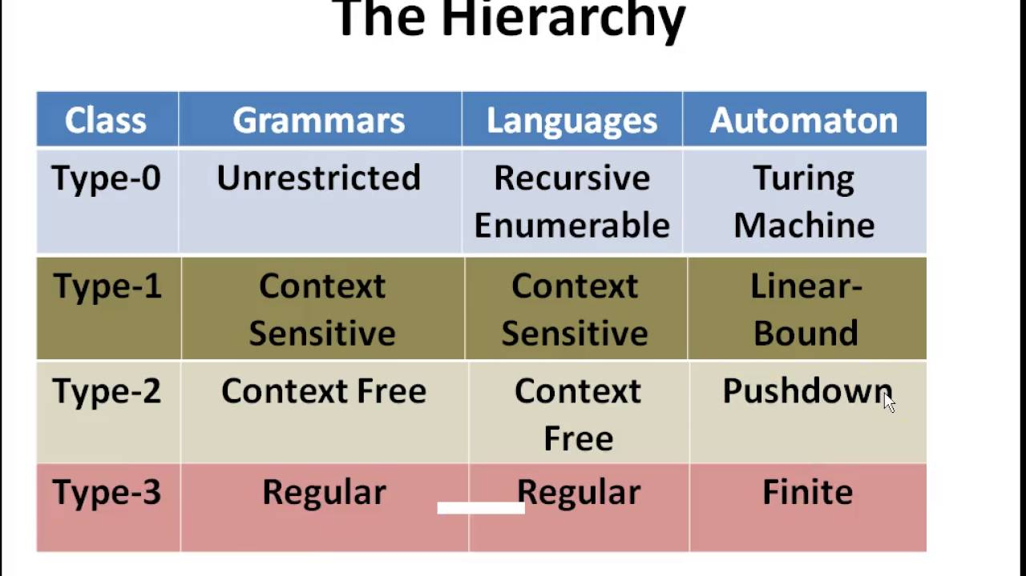

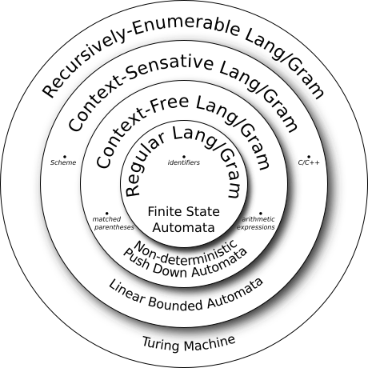

Type 0 Grammar (Unrestricted Grammar)

Type 0 grammar language are recognized by Turing machine.Type-0 grammars generate recursively enumerable languages. The productions have no restrictions. They are any phase structure grammar including all formal grammars. They generate the languages that are recognized by a Turing machine. The productions can be in the form of α → β where α is a string of terminals and nonterminals with at least one non-terminal and α cannot be null. β is a string of terminals and non-terminals.

Example
S → ACaB
Bc → acB
CB → DB
aD → Db

Type 1 Grammar (Context Sensitive)
Type-1 grammars generate the context-sensitive languages. The language generated by the grammar are recognized by the Linear Bound Automata
In Type 1
Grammar Production in the form of
i.e count of symbol in α is less than or equal to β
For Example,
S –> AB
AB –> abc
B –> b

Type 2 Grammar(Context Free )
Type-2 grammars generate the context-free languages. The language generated by the grammar is recognized by a Non Deterministic Push down Automata.

Type-3 grammars must have a single non-terminal on the left-hand side and a right-hand side consisting of a single terminal or single terminal followed by a single non-terminal. The productions must be in the form X → a or X → aY, where X, Y ∈ N (Non terminal) and a ∈ T (Terminal)

The rule S → ε is allowed if S does not appear on the right side of any rule.

Example
X → ε
X → a | aY
Y → b

Type 3 Grammar (Regular Grammar)

Type-3 grammars generate the regular languages. Type-3 grammars must have a single non-terminal on the left-hand side and a right-hand side consisting of a single terminal or single terminal followed by a single non-terminal. The productions must be in the form X → a or X → aY, where X, Y ∈ N (Non terminal) and a ∈ T (Terminal)

Example
X → ε
X → a | aY
Y → b

Decidability and Un Decidability Problems

A language is called Decidable or Recursive if there is a Turing machine which accepts and halts on every input string w. Every decidable language is Turing-Acceptable.
For a decidable language, for each input string, the TM halts either at the accept or the reject state as depicted in the following diagram −
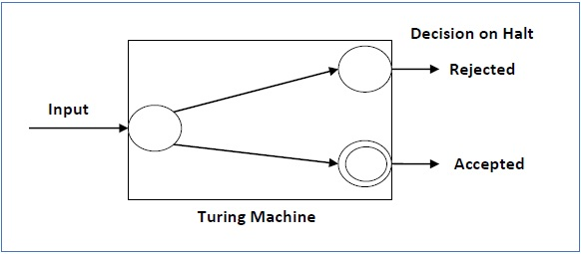

For an undecidable language, there is no Turing Machine which accepts the language and makes a decision for every input string w (TM can make decision for some input string though). A decision problem P is called “undecidable” if the language L of all yes instances to P is not decidable. Undecidable languages are not recursive languages, but sometimes, they may be recursively enumerable languages.

